<https://handsonreact.com/docs/labs/ts/RunningYourProject>

**Lab 2: Running Your Project**

**Objectives**[**​**](https://handsonreact.com/docs/labs/ts/RunningYourProject#objectives)

* Run the project
* Make a change and see the app update
* Stop the project

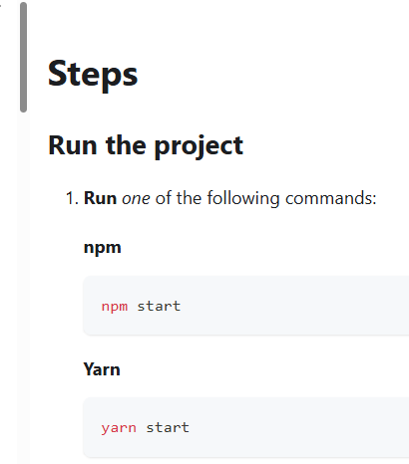

C:\Users\Family\git\keeptrack> npm start  
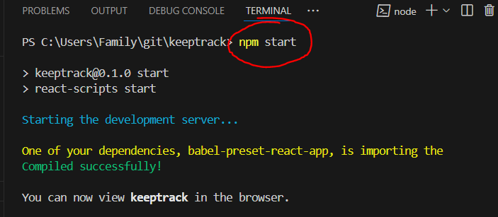

  
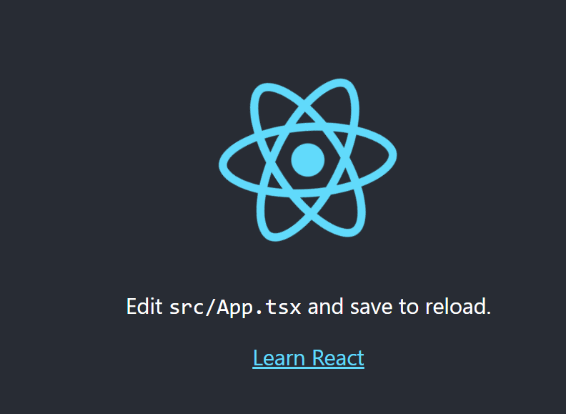

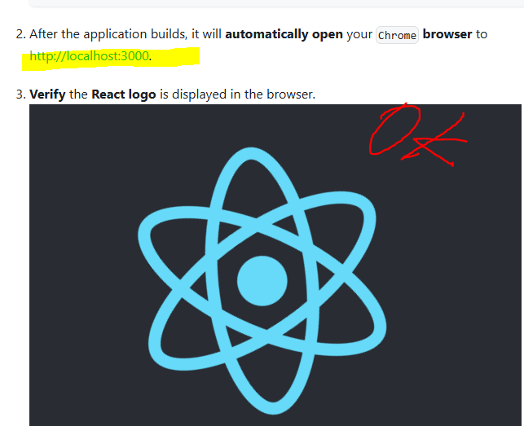

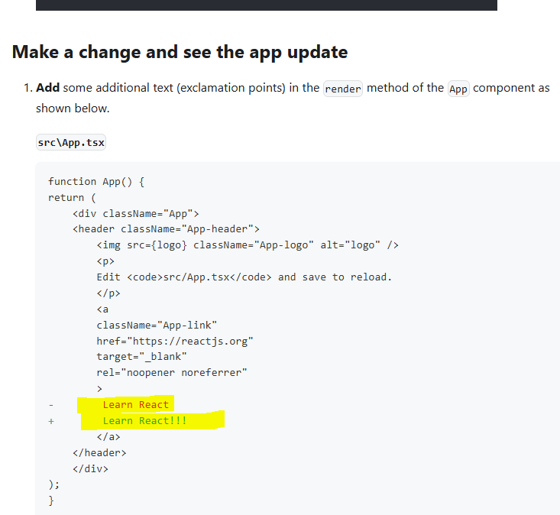

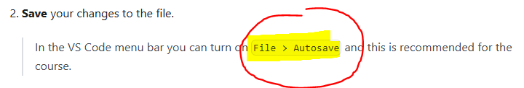

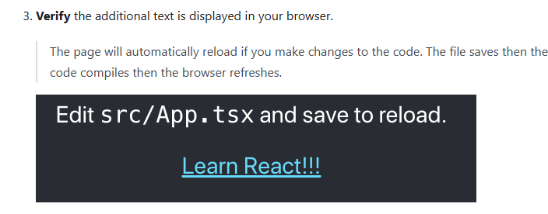

* Learn React!!

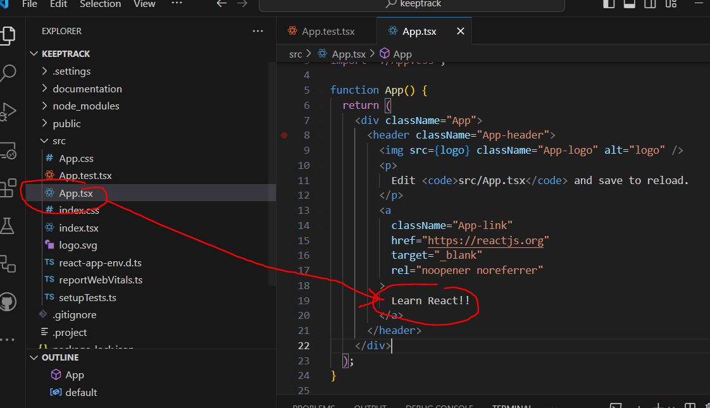

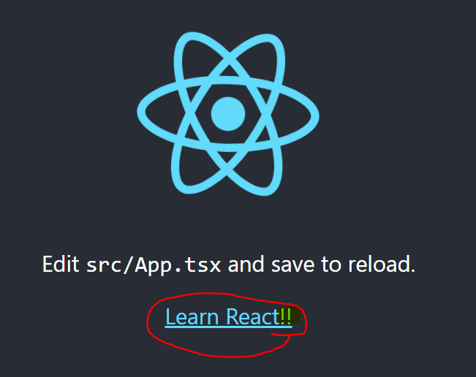

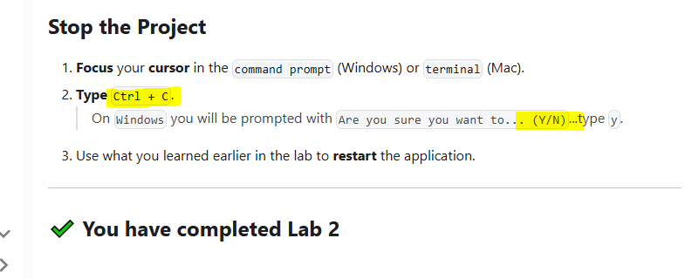

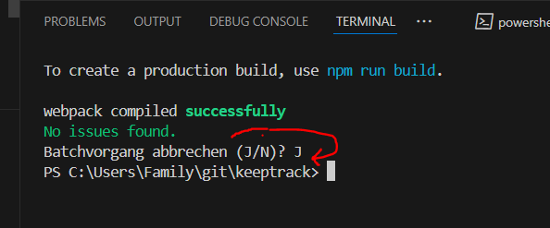

PROJECT WAS STOPED 😊